DELIVERABLE 5
CSCE 5430
GROUP 10

Lohith Kumar Velkuri
Vynatheya Reddy Vuppunutula
Kiran Kumar Raju Ganga Raju
Srikanth Reddy Ettem

TABLE OF CONTENTS
- Requirements
  - Admin Portal Changes
  - Zip Code for Event
  - Logout for Users from Homepage
  - New Table in Database for Tickets
  - Email Verification for Registration
  - Password Reset
  - Handling Duplicate Emails and Usernames
  - Payment Page
  - Ticket Confirmation Page
  - Email Receipt for Ticket Purchase
  - Session Management
  - Booking History
- UML Design
  - Class Diagram
  - Sequence Diagram
  - Use case Diagram
- Test Cases
  - Generate Random Code
  - Password Encryption
  - Testing Ticket Booking Feature
  - Testing Cost Calculation
- Breakdown of Team Roles and Responsibilities
- User Manual
- Compiling/Running Program and Test Cases
- Future Scope
  - Real-time Payment
  - Consumer to Consumer Model
- Member Contribution Table

REQUIREMENTS
The following components/features were developed during this phase:
- Admin Portal Changes
- Zip Code for Event
- Logout for Users from Homepage
- New Table in Database for Tickets
- Email Verification for Registration
- Password Reset
- Handling Duplicate Emails and Usernames
- Payment Page
- Ticket Confirmation Page
- Email Receipt for Ticket Purchase
- Session Management
- Booking History

Admin Portal Changes
In the previous phase of the project, the admin login was from within the homepage itself. In this phase, we have made a new login flow such that the admin portal can be accessed separately from the webpage available to the public. Moreover, we also have added the function of adding zip code to the events by the admin.

Zip Code for Event
This feature allows filtering of events using zip code assigned to them.

Logout for Users from Homepage
Logout button has been implemented in this phase for users to exit their accounts after use or completion of session.

New Table in Database for Tickets
This table in the database would include information about the tickets such as number of tickets available, sold, ticket IDs and so forth.

Email Verification for Registration
An email would be sent to the email address provided by the user at the time of registration. The user would be required to confirm their email by responding to the link sent to their address, which would then allow them to create their accounts.

Password Reset
This option enables the users to change their passwords. In situations where users may forget their password, this feature also provides the option of resetting their password by sending a password reset link to their registered emails.

Handling Duplicate Emails and Usernames
Multiple accounts with a single email and/or username are not allowed. Only one account may be created using a specific email and a username that has already been taken by one user cannot be used by another new user.

Payment Page
In this page, the users enter their card details for payment. Since our web application does not include real-time transactions, we have used a simple form where users may enter details to continue their ticket purchase.

Ticket Confirmation Page
After completing payment, a ticket confirmation page is generated which includes information about the event and also has a unique ticket ID generated for every purchase.

Email Receipt for Ticket Purchase
After successfully purchasing tickets from the web application, an email confirmation would be sent to the user about the transaction.

Session Management
This feature maintains the state of the user from the time of login to the time of logout. We implemented this by using HttpSession.

Booking History
This feature allows the users to view their booking history which includes previously booked tickets for past events.

2. UML DESIGN

Class Diagram

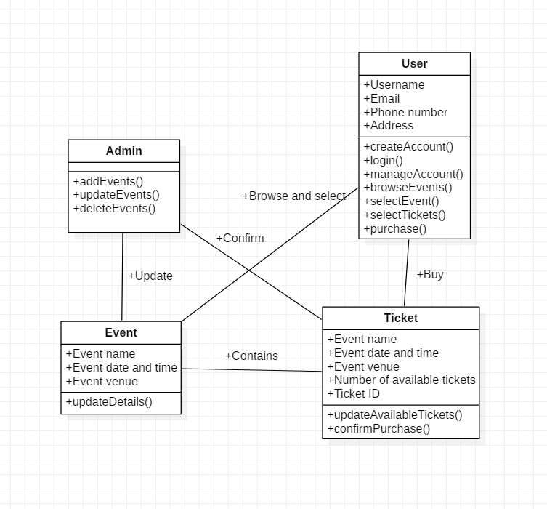Figure 2.1.1. Class Diagram

Sequence Diagram
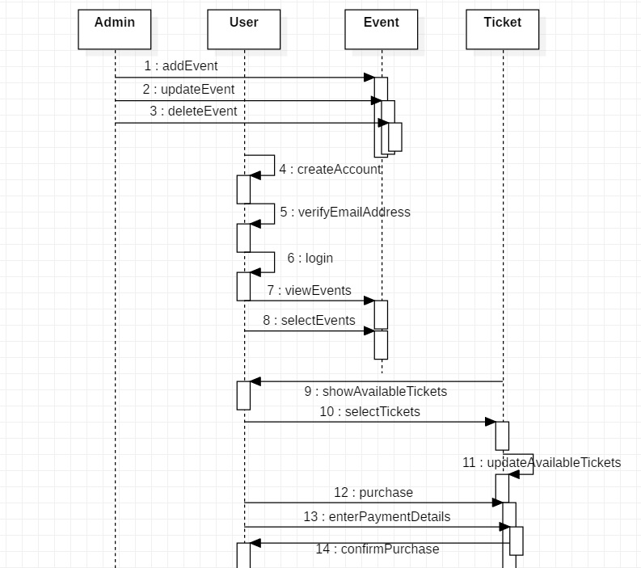
Figure 2.2.1. Sequence Diagram

Use Case Diagram
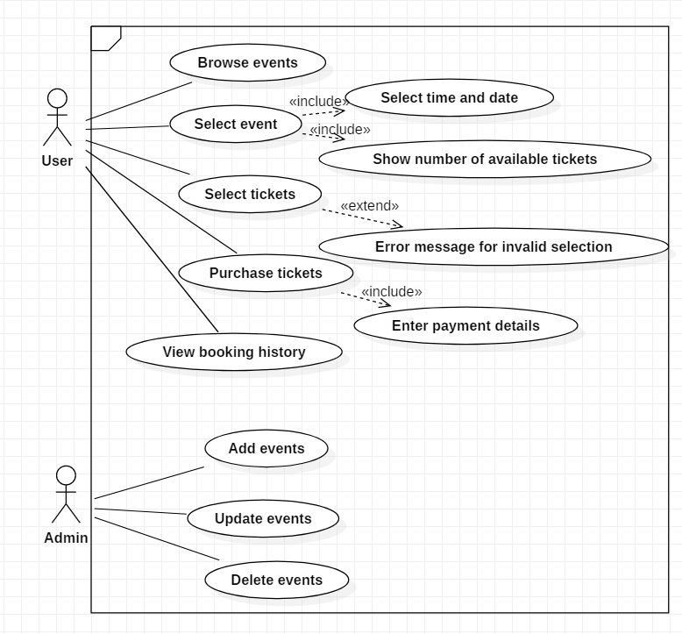
Figure 2.3.1. Use Case Diagram

TEST CASES

Generate Random Code
Description: It checks whether the program is returning the random code out of the given input list of numbers.
Input: String
Output: String
Test Code:
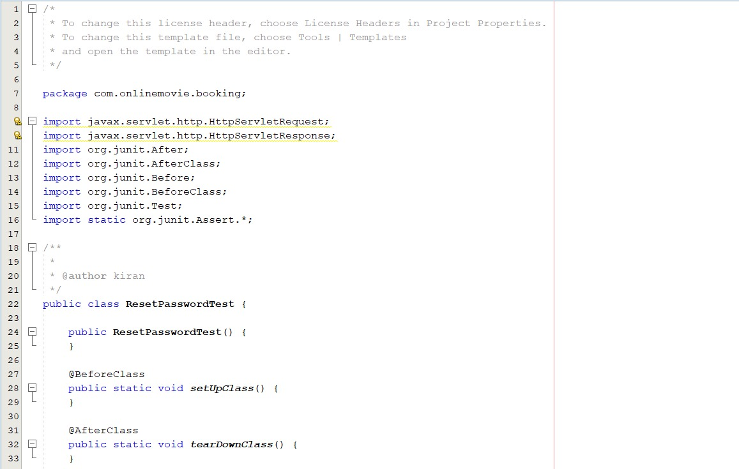
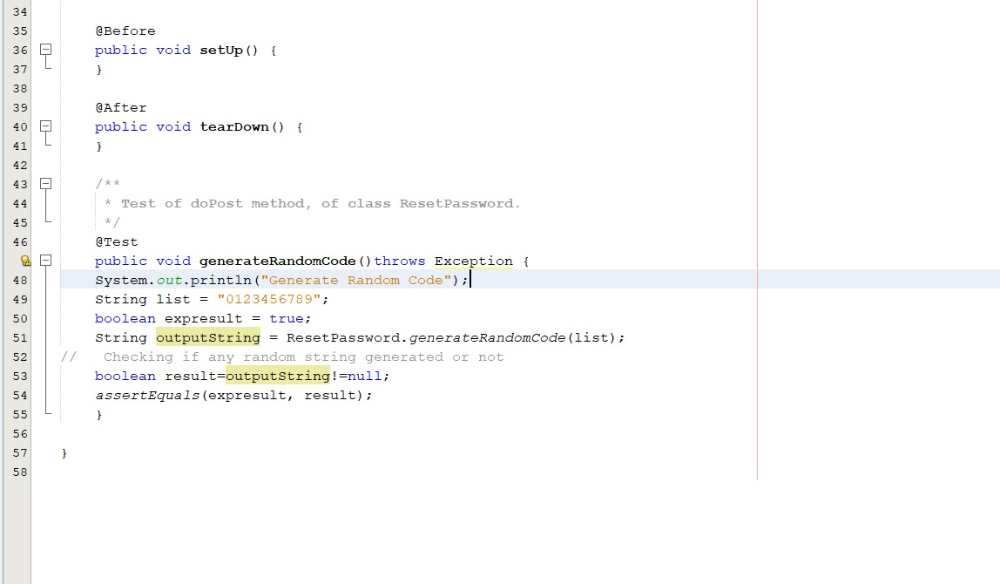
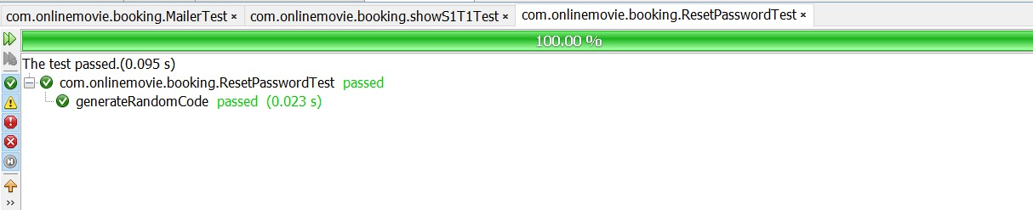

Password Encryption
Description: This case tests for the correctness in the encryption of passwords. Passwords were encrypted using SHA-256.
Input: Password entered by the user
Output: SHA-256 hashed password
Unit Test Code:
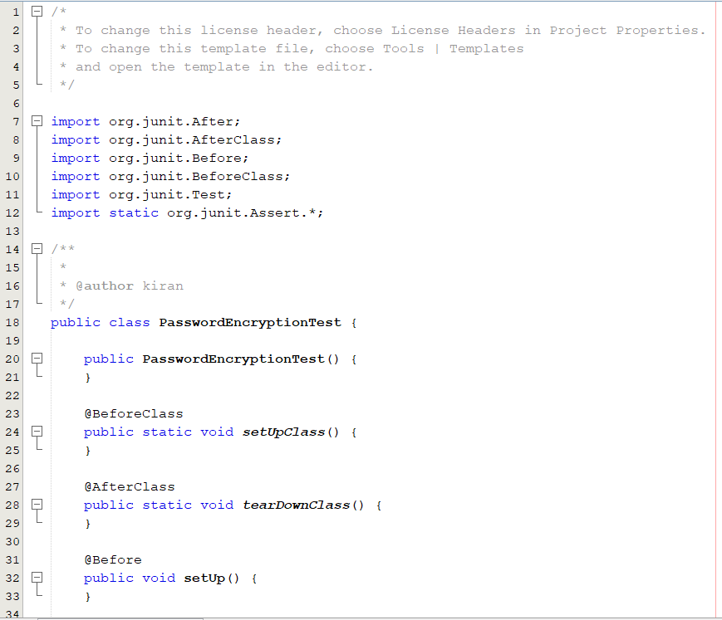
Positive case (Password string and its corresponding hash are entered)
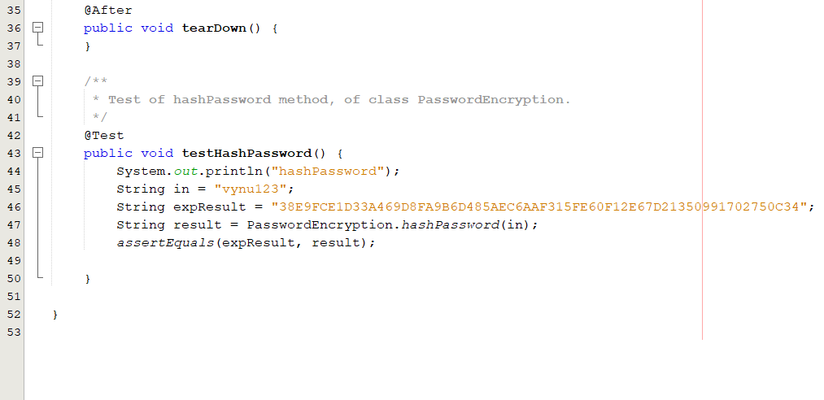
Result
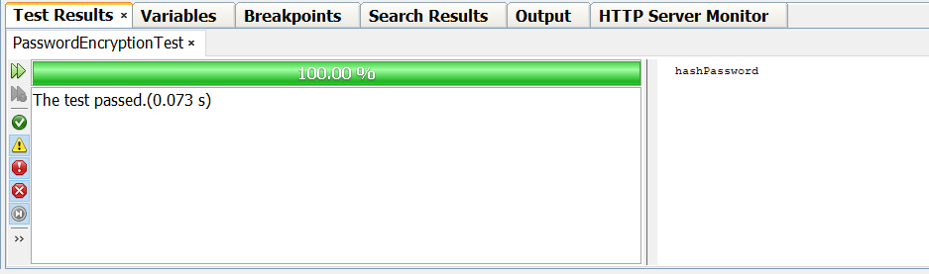
Negative case and result
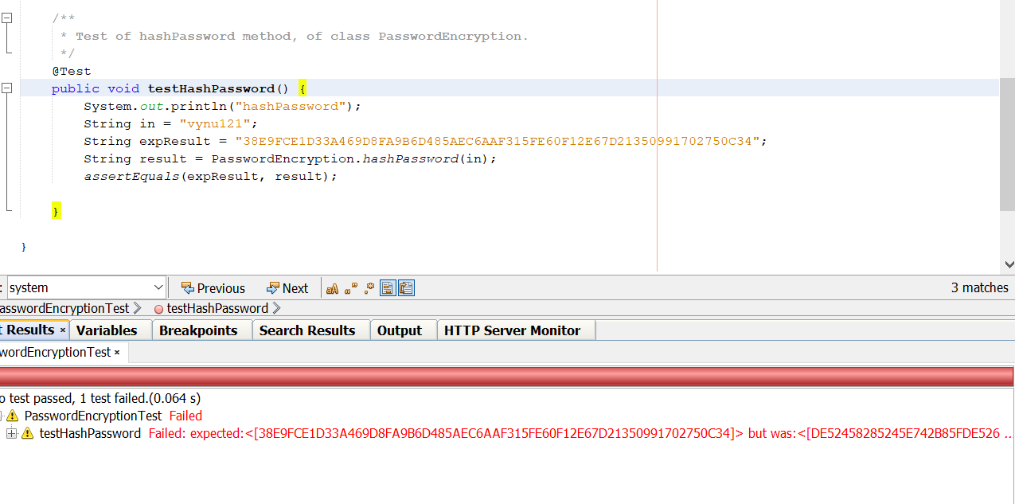

Testing Ticket Booking Feature
Description: This case tests for the correctness in booking the required tickets out of available tickets. This means a user should not be allowed to book more than the available tickets.
Input: The number of tickets the user is requesting to book. ( 1 to 100 – valid input)
Output: True, if the requested tickets is less than available or False, otherwise
Unit Test Code:
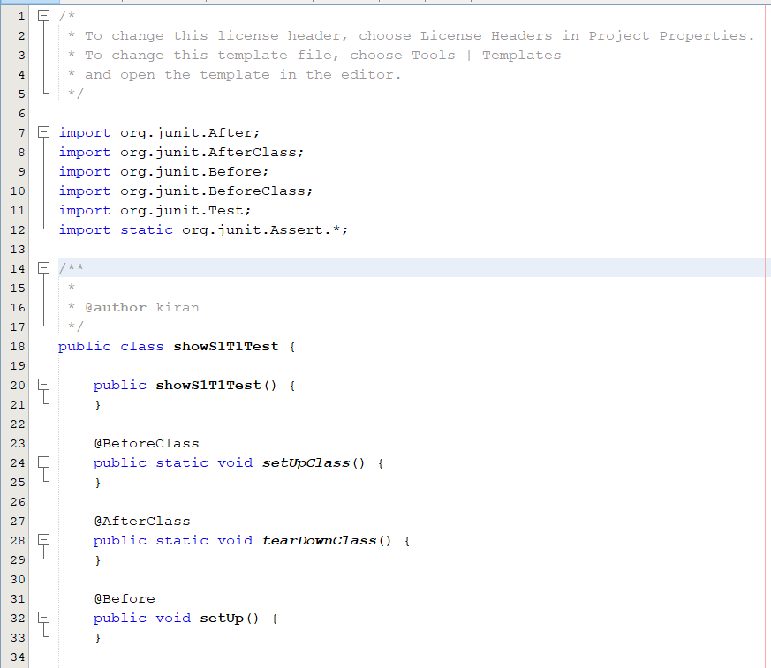
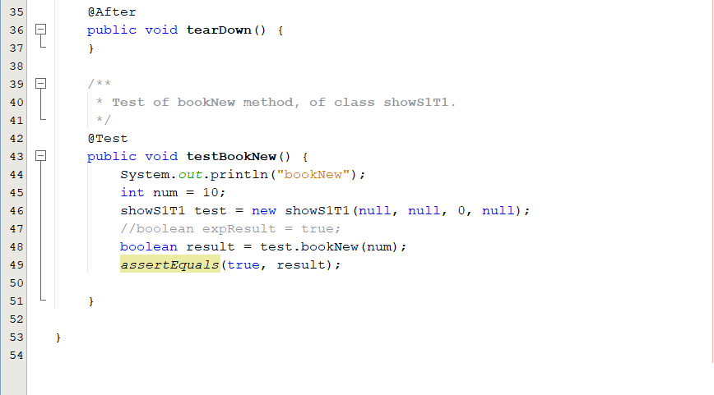

Positive case : (Input is in range i.e., 1 to 100)
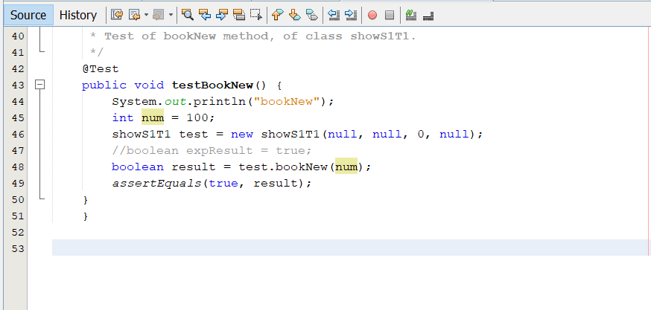

Result:
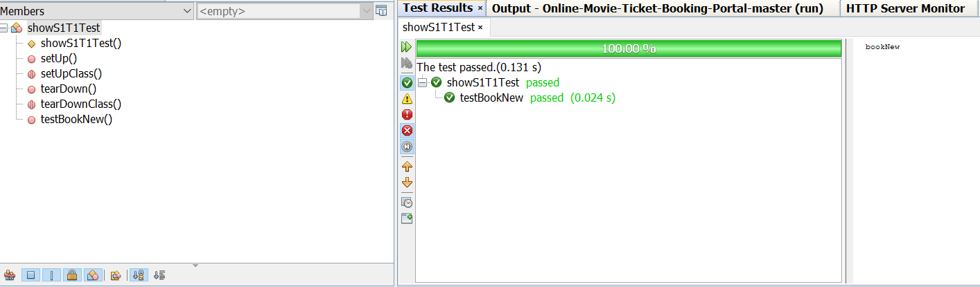

Negative case : (Input is a negative integer)
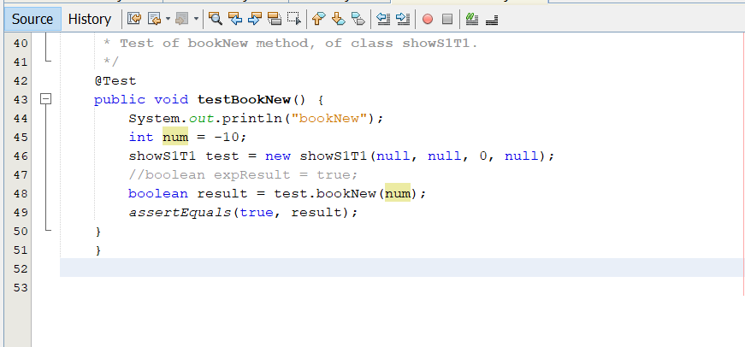
Result:
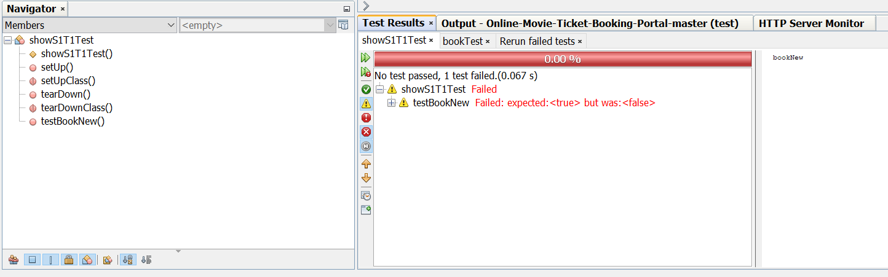

Out of Bounds case: (Input is greater than 100)
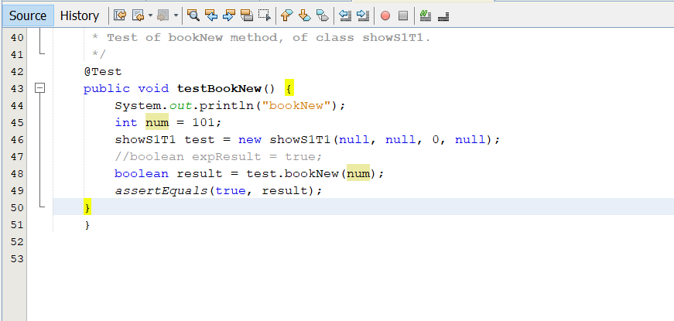
Result:
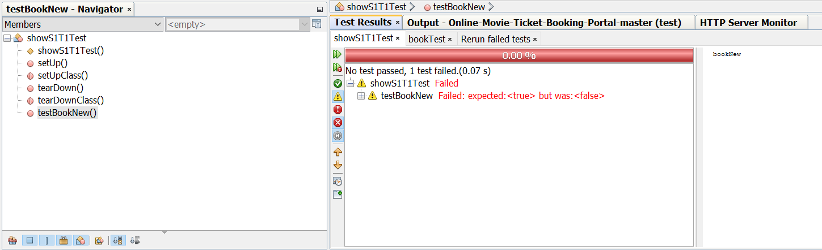

Testing Cost Calculation
Description: This case tests if the program is calculating the cost correctly based on the user selected class value (i.e., silver or gold or platinum).
Input: String with class value (silver or gold or platinum)
Output: cost of the ticket in integer form
Unit Test Code:

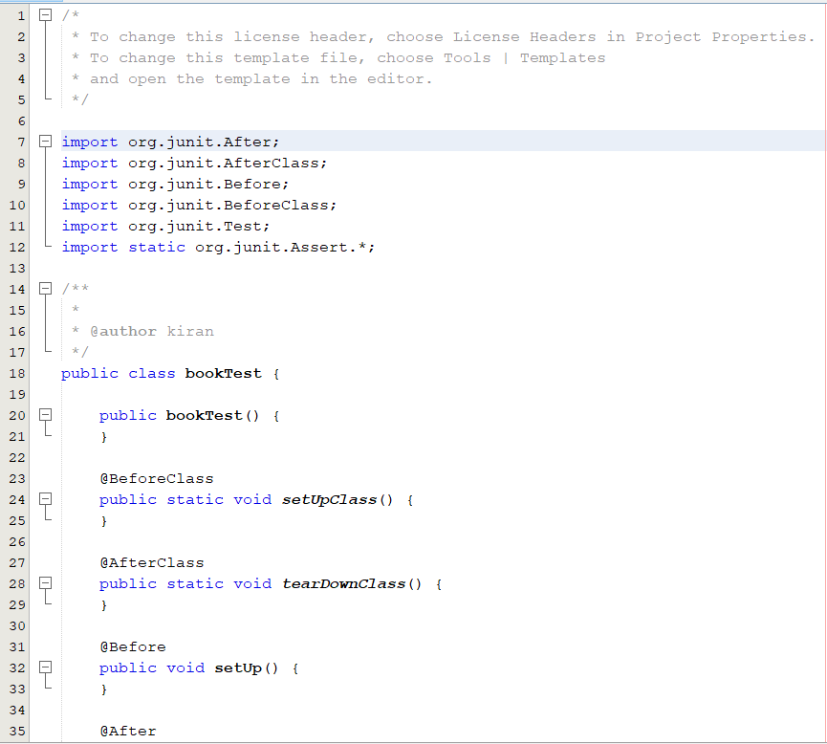
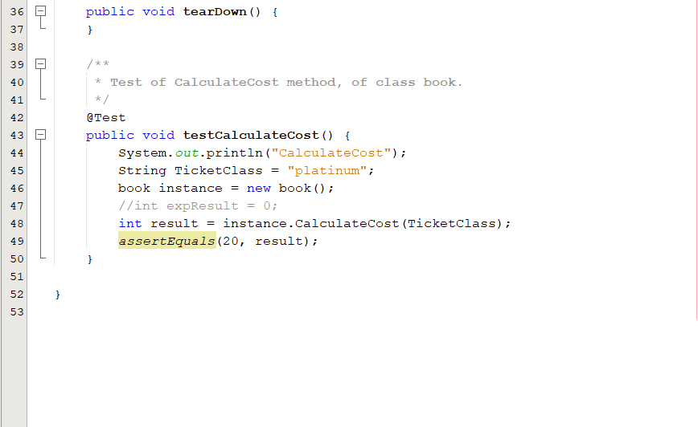

Positive case: (Input is either silver or gold or platinum)
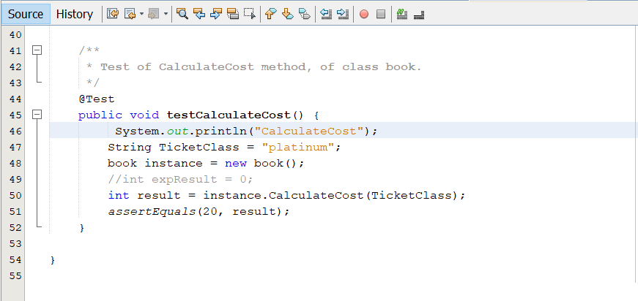

Result:
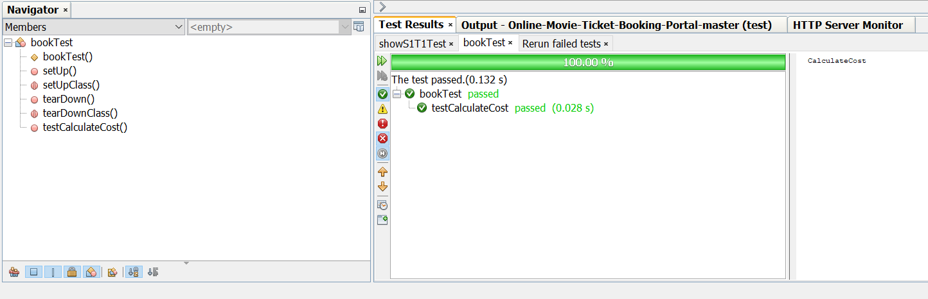

Out of Bounds case: (input is any string other than silver or gold or platinum)
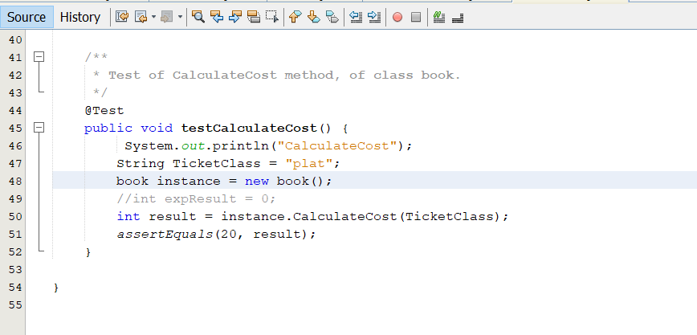
Result:
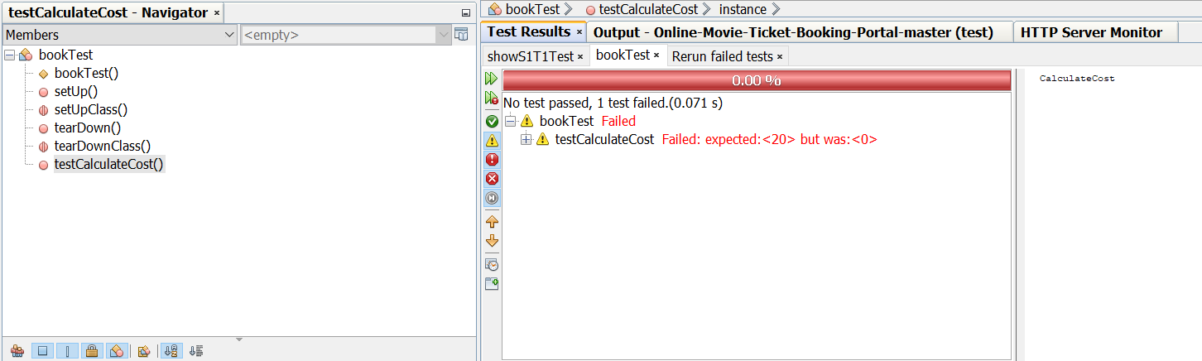

BREAKDOWN OF TEAM ROLES AND RESPONSIBILITIES
- Lohith Kumar Velkuri: Zip code filtering, Session management, Handling duplicate usernames and emails
- Vynatheya Reddy Vuppunutula: Admin portal changes, Database changes, Ticket generation
- Srikanth Reddy Ettem: Booking history page, Payment page
- Kiran Kumar Raju Ganga Raju: Email verification for registration, password reset, and ticket receipt

USER MANUAL
In order to user our program, initially, the end-user needs to install a few softwares on their local computer.
Firstly, our application is developed using Java, which is an object-oriented programming language. We used the latest version of Java, which is Java 1.8, or Java 8. The end-user has to download the software. This can be done using the following URL:
https://www.oracle.com/technetwork/java/javase/downloads/jre8-downloads-2133155.html
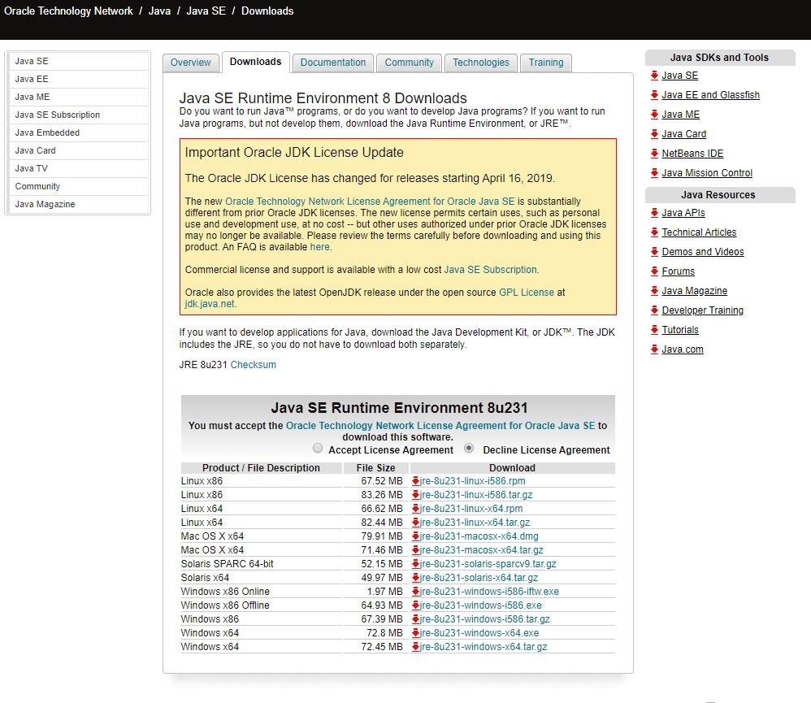

Depending upon your operating system and the bit size (32 bit or 64 bit), you need to select and download the software.
Once you install the software, you need to set class path in your computer. You need to go to Control Panel->Environment Variables->Class Path
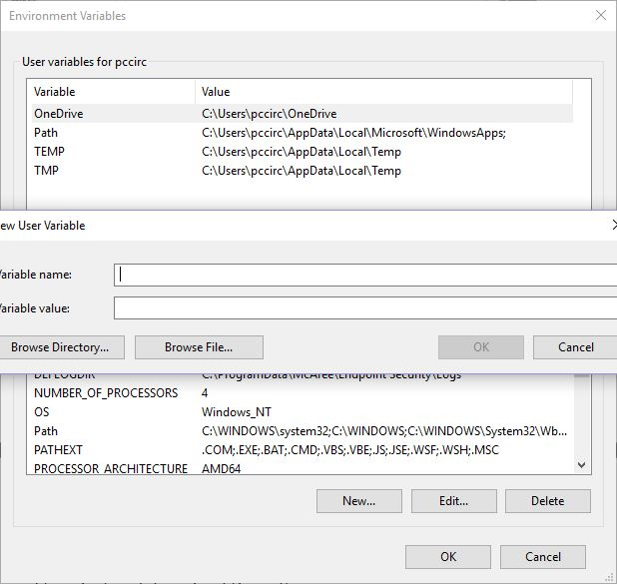

You need to enter the JDK and JRE class paths over here. Next, you need to open command prompt and type Java and Javac to check whether the installation was done properly or not.
Secondly, we need a database for every enterprise application to store repository of data. We have been suing MYSQL Server 5.5 database for our application. We can download that using the following URL:

https://dev.mysql.com/downloads/mysql/5.5.html
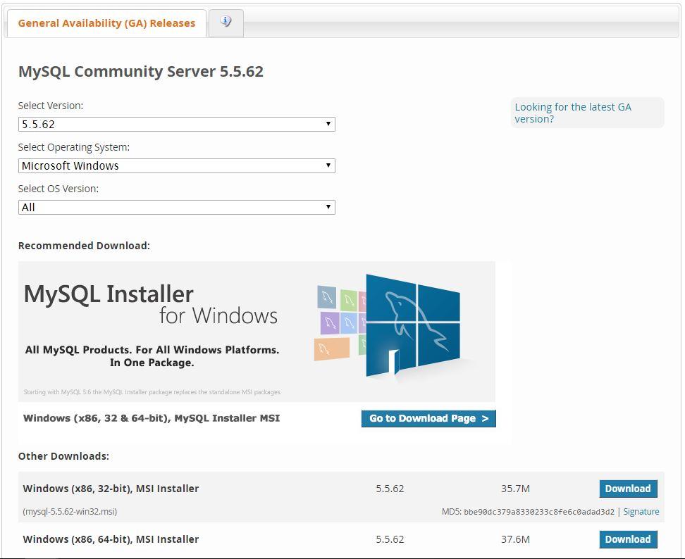

Once you are done with the installation, you need to open movieportal.sql file. This file contains the database commands, etc.
We had created Database UserDB.
We had created table structure for Users using CREATE command.
CREATE TABLE TABLENAME (Variable1 Type1, Variable2 type2, );
We had also created tables for Shows and movie database using the same CREATE command.
Next, we had dumped data into these tables by inserting data into it using INSERT command,
INSERT INTO table name (column1, column2, column3,)
VALUES (value1, value2, value3,);

Once we are done with the installation of Java and MYSQL server, we need to install an IDE.
We are using Net beans IDE in order to execute our open project. We can install it by using the URL:
https://netbeans.org/downloads/8.2/
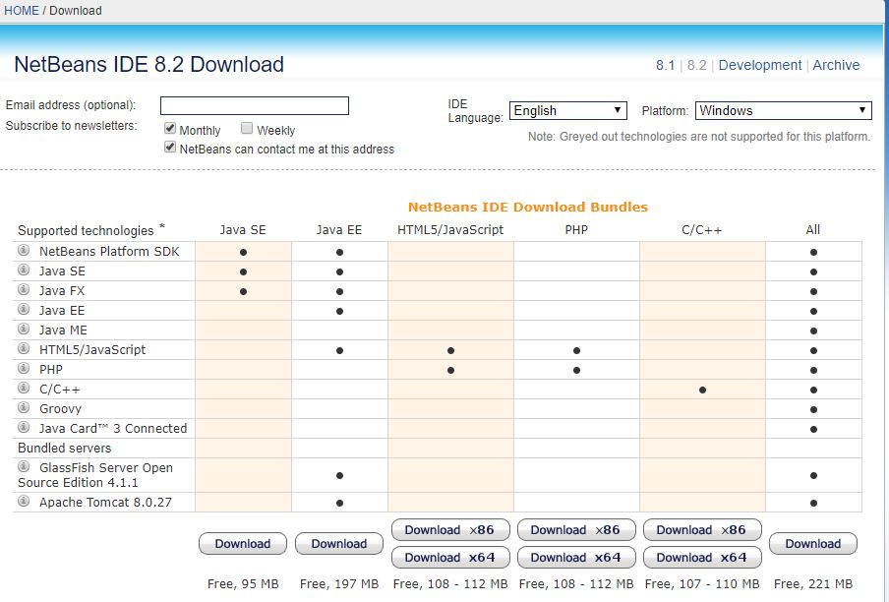

Net Beans IDE helps you execute your web application easily since it has in-built servers, provides clear overview of enterprise applications and it provides different perceptions of our data.
Along with these softwares, we have been using JDBC (Java database connectivity) in order to maintain communication between the database and the server. We have been using JDBC type 4 driver for establishing the connection.
Once you have downloaded all the softwares and while executing the application on your local machine, if the end user encounters any error, then he/she needs to delete the current JDBC driver and needs to install it again.
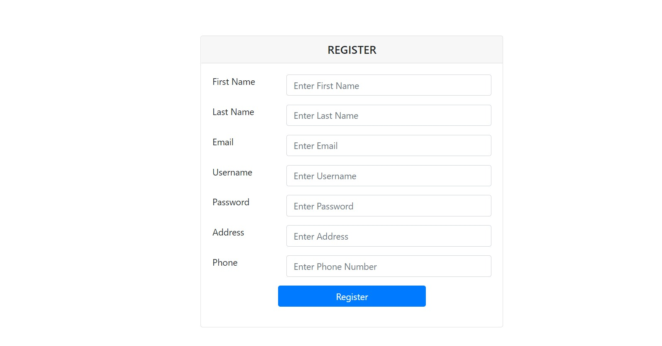
The above picture shows the registration page. New users to the web application would need to create their account by providing their details such as first name, last name, email, username, password, address and phone number. The system checks for unique username and email. An email is sent to the user’s email address asking them to verify their email. After email verification is complete, the user’s registration is complete and the user can then login.
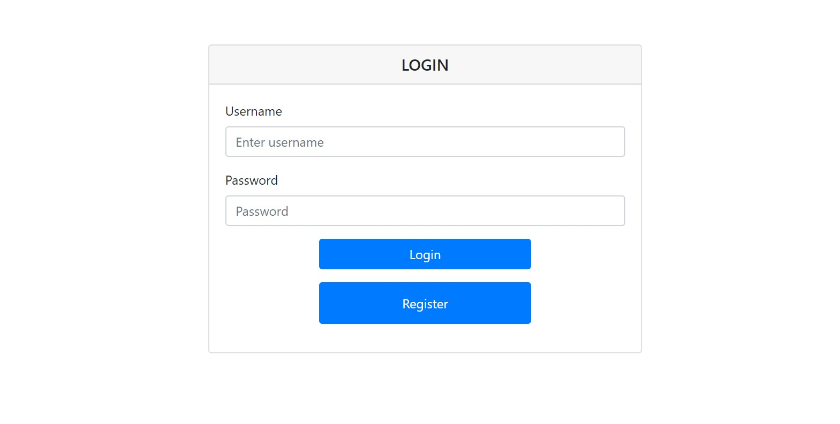
After registration is complete, the user needs to login to his/her account. For this, the user needs to enter their username and password. Upon successful login by entering the correct credentials, the user would be directed to the homepage of our web application.
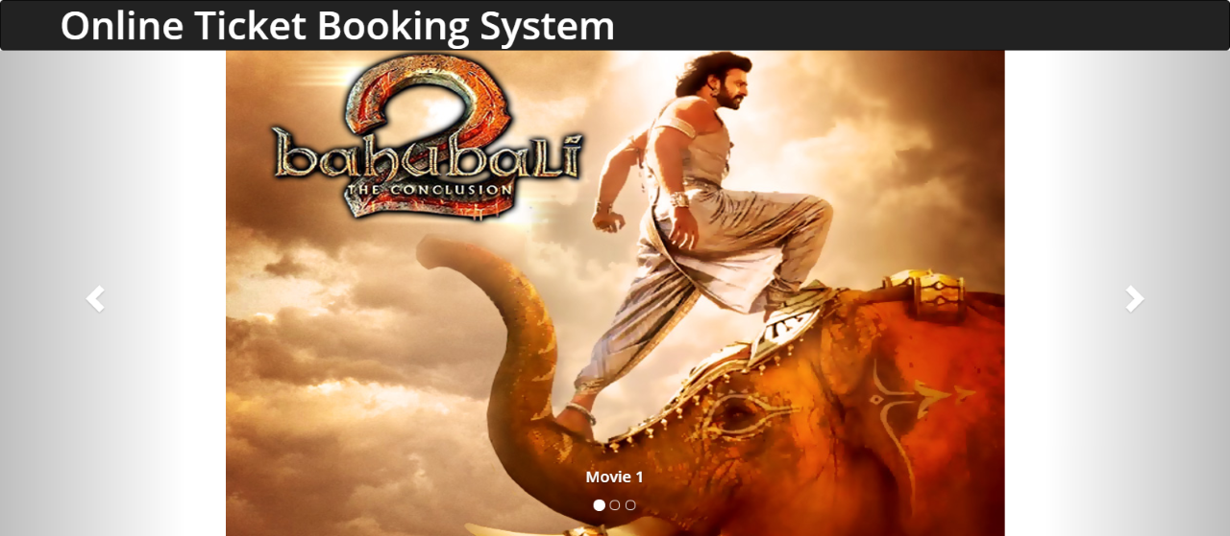

The homepage for our web application mainly deals with booking event tickets. As soon as the customer opens the web application, he/she will be able to view the list of movies that are available to book the tickets.
First, the customer has to select a particular event from the pool. The pool can be filtered using the zip code to search for nearby events. He/she will be able to view the details about the event like show timings, duration, screen number, number of tickets available.
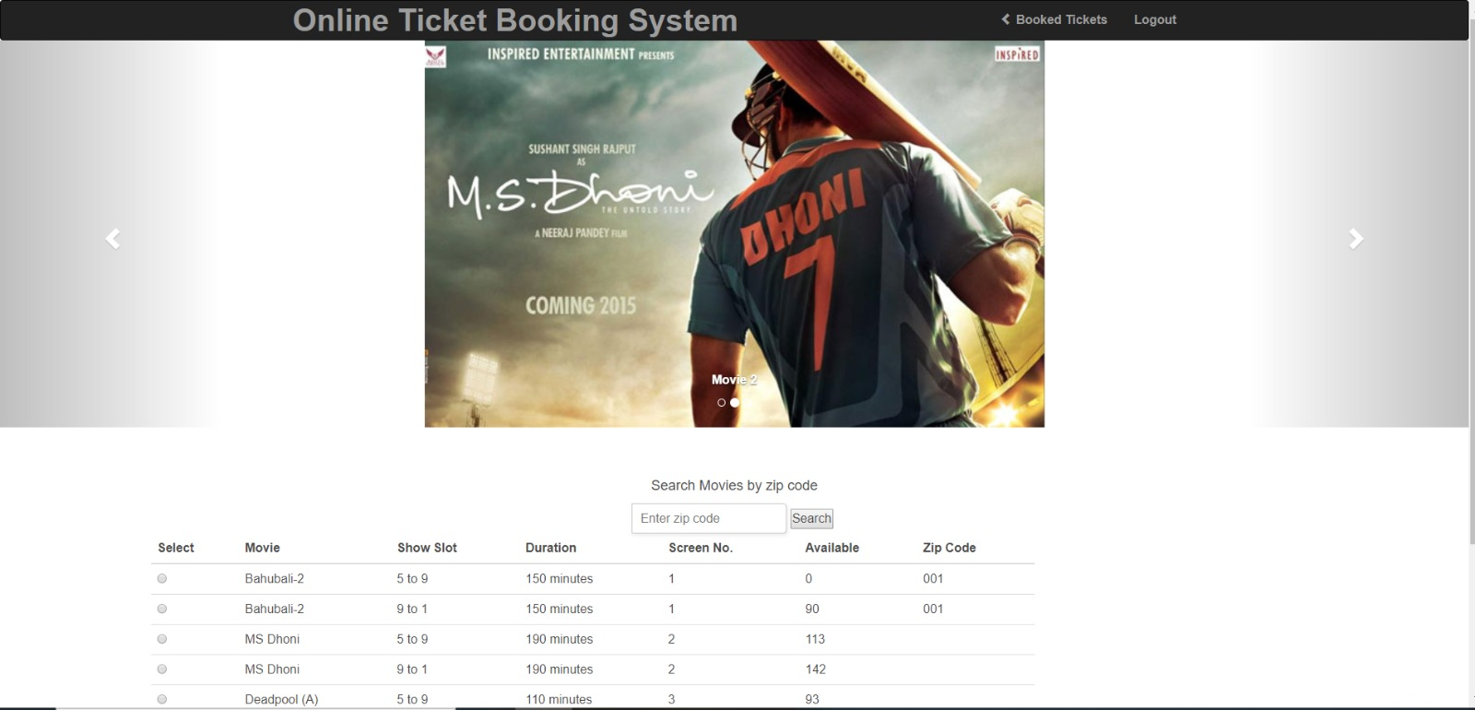

Once the customer had decided to select a movie, he/she has to select the number of tickets. Usually the number of tickets ranges from zero to number of tickets available at that moment.
The tickets are classified into three categories:
Silver: $10
Gold: $15
Platinum: $20
Once you are done with selecting the number of tickets, you need to click on Book Now button. This would take the user to a payment page where the user needs to enter their card details/payment information. After entering the payment details, the tickets would be successfully purchased.
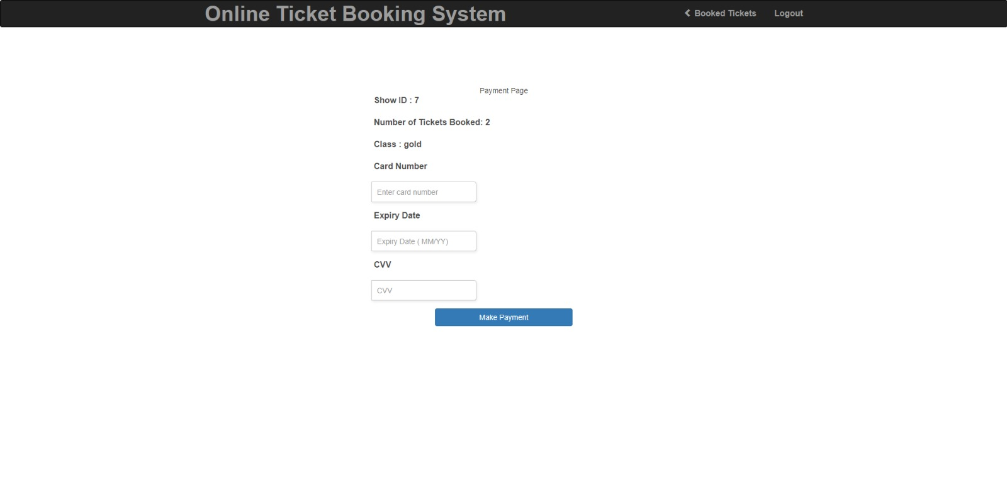
You will be redirected to the next page, which is the ticket confirmation page. Here, you will be able to view the summary of the ticket and the amount required to be paid. The ticket generated also has a unique ticket ID generated for every unique purchase.
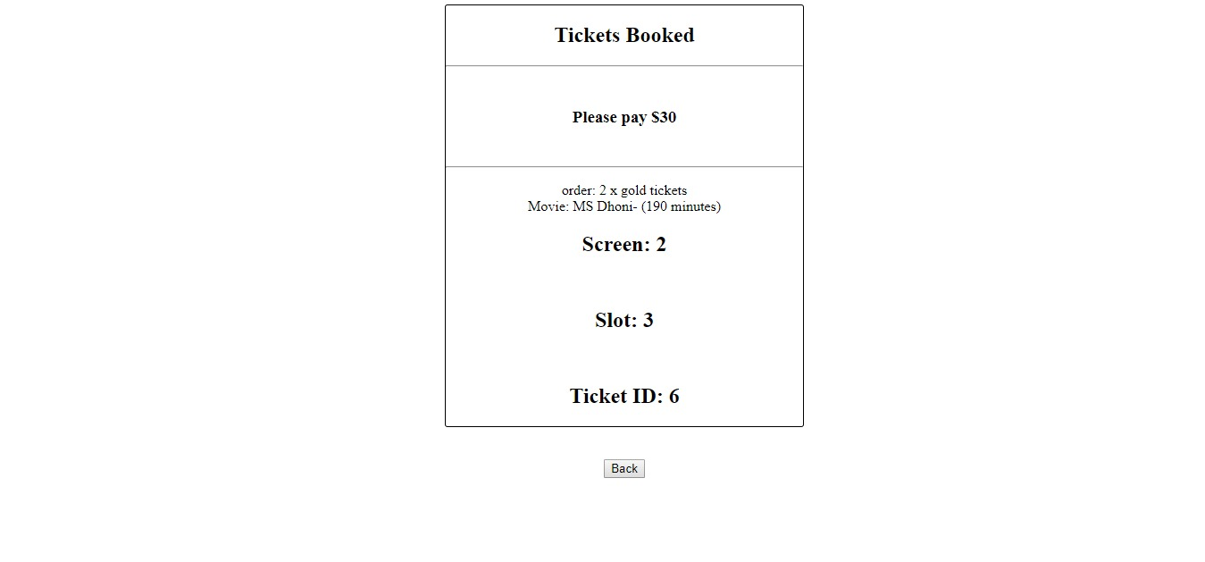
The user can also view a history of previous bookings.
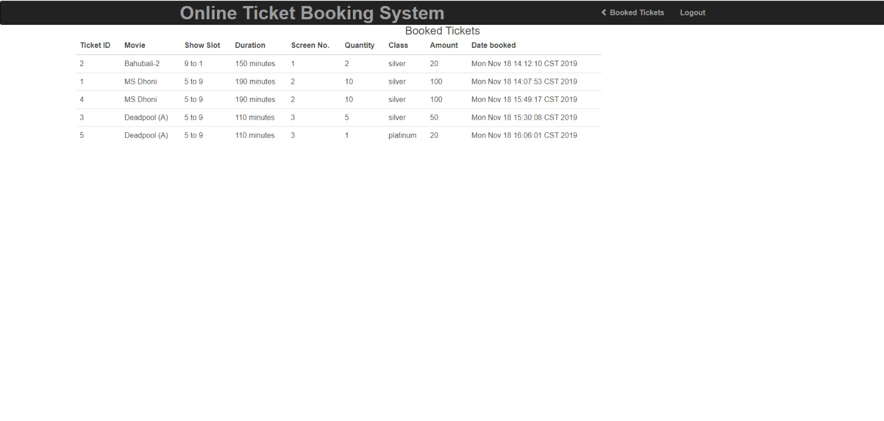
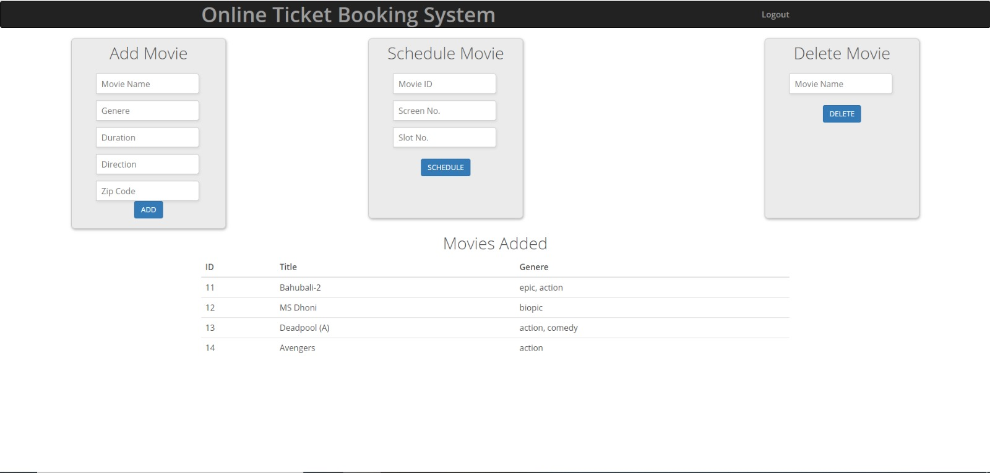
The above figure shows the admin page. The admin has three functionalities: add events, update/schedule events and delete events.
Credentials for admin login
Username: lohith123
Password: lohith123
Credentials for user login
Username: lohith123
Password: lohith123

COMPILING/RUNNING THE PROGRAM AND TEST CASES
Running the test cases:
To run the test cases,
1. Right click on the test file
2. Click on run test. This will run the existing test cases automatically with the values provided manually in each test case.

Executing the code:
1. Open the project in Netbeans (We opted this as it has In-built server)
2. Right click on main project file
3. Click on clean and build
4. Now once the build is succeeded, click on run
5. This will start the server and will try to open it in the default browser set in the Netbeans
6. If the browser does not open, copy the URL from the run section and try to load the page.
7. If facing any errors related to JDBC driver connection, we need to remove the JDBC driver from Libraries folder in Netbeans and try to add the driver again. Now, without running the project again, reload the browser.

FUTURE SCOPE

Real-time Payment
In the future, we could implement real-time payment system such as using real credit card information and other payment methods such as online banking, Paypal, etc.

Consumer to Consumer Model
Users could also add their own events through our web application to which other users can buy tickets to.

MEMBER CONTRIBUTION TABLE
Member Name | Contribution Description | Overall Contribution (%)
Lohith Kumar Velkuri | Components: Homepage, Backend Java code, Zip code filtering, Session management, Handling duplicate usernames and emails  Report: How to run and compile the program | 25%
Vynatheya Reddy Vuppunutula | Components: Booking functionality, Password encryption, Admin portal changes, Database changes, Ticket generation  Report: Requirements, UML Design | 25%
Srikanth Reddy Ettem | Components: Database design, User Interface, Booking history page, Payment page  Report: User Manual | 25%
Kiran Kumar Raju Ganga Raju | Components: User Interface, Test Cases, Email verification for registration, password reset, and ticket receipt  Report: Test Cases | 25%

